Superstore Sales Analysis Report
Introduction
This report presents an in-depth analysis of sales trends, product performance, and customer behavior for the Superstore dataset. Leveraging Excel for data cleaning and Power BI for visualization, the analysis provides actionable insights to drive strategic decisions, enhance sales efficiency, and improve profitability.

Overview
The analysis covers:
- Product-level performance
- Monthly sales trends
- Category-wise and regional revenue distribution
- Customer purchasing behavior
The goal is to identify patterns and opportunities that can inform business strategies.
Objectives
- Identify best-selling products to guide inventory and marketing strategies.
- Analyze monthly sales trends to pinpoint peak periods and seasonal fluctuations.
- Evaluate category-wise performance to highlight high-revenue segments.
- Assess regional revenue distribution to identify growth markets.
- Understand customer behavior and segment preferences for targeted strategies.

Data Preparation
Tools Used: Excel and Power BI
Key Steps:
- Removed unnecessary or duplicate columns
- Standardized text fields for consistency
- Corrected date and numeric formats
- Handled missing values
- Ensured sales, profit, and discount data were accurate
- Imported cleaned data into Power BI for visualization

Dashboard Overview
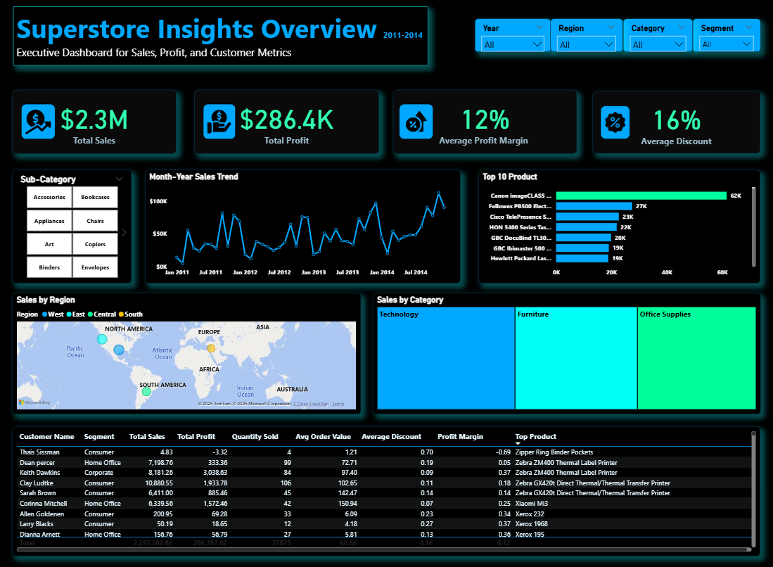

Key Insights
- Organizational supplies lead in sales volume, reflecting strong demand for essential office consumables. Top items are Staples (215 units), Binder Clips (179 units), Faxes (158 units), Staples in miscellaneous colors (154 units), and Storex Dura Pro Binders (152 units).
- Sales significantly peak in December, suggesting the highest revenue generation occurs at the end of the calendar year.
- Technology outperforms other categories, generating $836K—nearly $95K more than Furniture ($742K) and $117K more than Office Supplies ($719K).
- The West region tops revenue at $694K, just ahead of the East ($679K), with Central ($501K) and South ($391K) trailing by $193K and $303K, respectively.
- Staples tops in units sold, but the real profit drivers are high-value tech and office equipment—led by the Canon imageCLASS Copier ($25.2K), Fellowes PB500 Punch ($7.7K), HP LaserJet Printer ($7K), Canon PC1060 Copier ($6K), and Cisco IP Phone ($5.7K).
- New York City leads in profitability, generating $62K in total profit.
- Consumers dominate the customer base, placing 5,191 orders—almost half of all orders—followed by Corporate (3,020) and Home Office (1,783).
- Binders face steep discounts (37.3%), turning them unprofitable. Aggressive discounting here risks eroding overall store profits.

Recommendations
- Review Binder discounting: bundle with high-margin items or limit to short-term promotions to protect profitability.
- Maximize Capitalization on the December Sales Peak: prioritize Q4 resources on high-margin Technology products to fully capitalize on the year-end sales surge.
- Invest Strategically in Underperforming Regions: drive growth in Central and South regions through focused marketing, tailored inventory, and stronger local management to balance nationwide revenue.
- Establish a Tiered Consumer Loyalty Program: launch a tiered loyalty program for Consumers, offering spend-based perks like early access, exclusive discounts, and free/expedited shipping to boost repeat purchases and CLV.
- Implement a High-Value Cross-Selling Initiative: cross-sell high-margin Technology products with Office Supplies at checkout and via sales teams to drive profit growth.
- Conduct a Mix/Pricing Audit for Office Supplies: review Office Supplies pricing to raise revenue via small price hikes on inelastic items like Staples, maintaining high sales volume.

Conclusion

This analysis provides a comprehensive view of Superstore’s sales performance, highlighting key products, seasonal trends, top categories, and high-revenue regions. Implementing these recommendations will enhance sales efficiency, boost profitability, and support strategic decision-making.

